[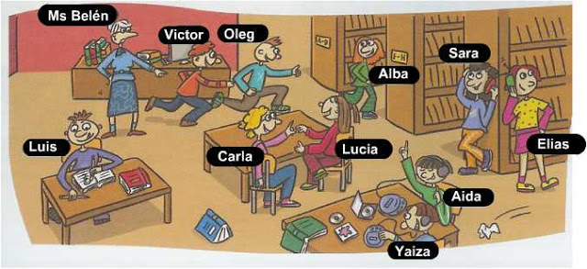](http://www.google.co.th/url?sa=i&rct=j&q=&esrc=s&frm=1&source=images&cd=&cad=rja&uact=8&ved=0ahUKEwixsPf_0q7JAhVLJI4KHa4hB98QjRwIBw&url=http%3A%2F%2Fapieceofcakeraquel.blogspot.com%2F2013%2F01%2Fpresent-continuous.html&bvm=bv.108194040,d.c2E&psig=AFQjCNFpNDNNg4At_6dJO-U3YpaGJSpDEQ&ust=1448646420403999)

[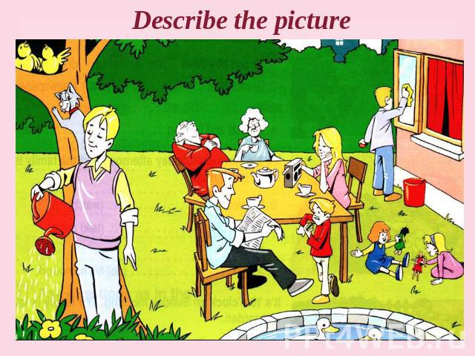](http://ppt4web.ru/anglijjskijj-jazyk/te-present-continuous-tense0.html)

[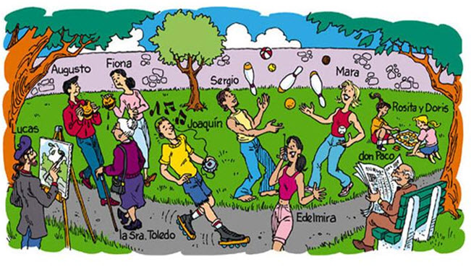](http://www.google.co.th/url?sa=i&rct=j&q=&esrc=s&frm=1&source=images&cd=&cad=rja&uact=8&ved=0ahUKEwjryaeD1K7JAhVHxY4KHTfTDv8QjRwIBw&url=http%3A%2F%2Fmyenglishclass.altervista.org%2Fpresent-simple-vs-present-continuous%2F&bvm=bv.108194040,d.c2E&psig=AFQjCNFpNDNNg4At_6dJO-U3YpaGJSpDEQ&ust=1448646420403999)

[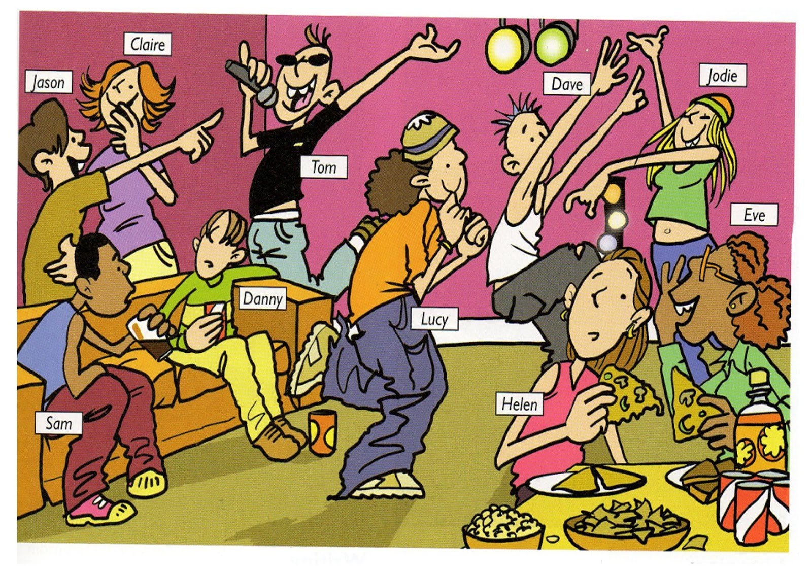](http://www.google.co.th/url?sa=i&rct=j&q=&esrc=s&frm=1&source=images&cd=&cad=rja&uact=8&ved=0ahUKEwiH8Ivh0q7JAhVWkY4KHSc_C_MQjRwIBw&url=http%3A%2F%2Fangles3rcicle.blogspot.com%2F2013%2F02%2Fimages-to-practice-present-continuous.html&bvm=bv.108194040,d.c2E&psig=AFQjCNFpNDNNg4At_6dJO-U3YpaGJSpDEQ&ust=1448646420403999)