A. Change to V.ing.
Verb | V. ing | Verb | V. ing
1. go |  | 11. eat
2. bark |  | 12. run
3. do |  | 13. jump
4. play |  | 14. sing
5. talk |  | 15. drink
6. brush |  | 16. brush
7. get up |  | 17. wait
8. swim |  | 18. watch
9. write |  | 19. wash
10. sit |  | 20. drive
B. Use the Present Continuous Tense of the verbs in the brackets.
1. She ................................... in the swimming pool now. ( swim ) 2. I ………………………………………… on the phone at this moment. (talk)
3. Bella ……………………………….dinner now. (cook)
4. They ………………………………all the questions. ( answer )
5. He ………………………………………… fast! (run)
6. Julia ……………………………… a chocolate cake at the moment. (bake)
7. I………………………………………… fun! ( have )
8. You ………………………………………very nicely. ( dance )
9. It ………………………………………… now. ( rain ) 10. John ………………………………………… salad, and I ………………… fish. (eat)
11. Marta ………………… under the tree ,but Chris …………………………………… in his clss.. (sleep)
12. The children ………………………………………… in the garden. ( run )
13. I………………………………………… my homework now. ( write )
14. We ………………………………………… on the new show right now. ( work )
15. Look! The old man ………………………………………… road. ( cross )

C. Make sentences.
1. 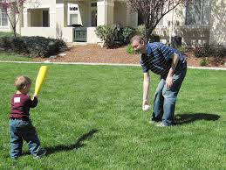 at this moment
= ………………………………………………………………………………………………..
2. 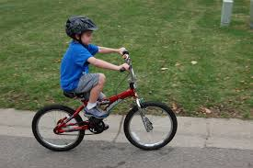
= ……………………………………………………………………………..
3. 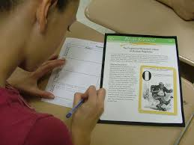 right now
= ……………………………………………………………………………………………………
4. 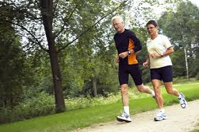 at present
=………………………………………………………………………………………………………….
5. 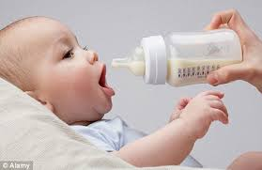 now
= …………………………………………………………………………………………………………..

