Excuse me. Where is the restaurant?
How can I go/get to….?

 I 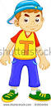
It’s ……..
Next…….
And…..….
Then…….
Finally…..

