Matching pictograph to chart

Day | Fish Caught
Thursday | 12
Friday | 48
Saturday | 42
Sunday | 18
Monday | 30

Day | Fish Caught
Thursday | 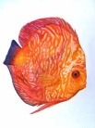
Friday
Saturday
Sunday
Monday

Each = 6 fish

