Fish Pictograph

Fish
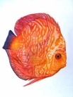
Thurs. Fri. Sat. Sun. Mon. Day

Each = 6 fish

