Worksheet 1: Place
- Directions: Complete the words and match the words with the pictures.
Name______________________________________ Class 1/___ Number_____

HOSPITAL BANK POLICE STATION
POST OFFICE SCHOOL PARK

 1. P _ _ _ O_ _ _ _ _
 2. S _ _ _ _ _
 3. HOSPITAL
 4. B _ _ _
 5. P _ _ _ _ _ S_ _ _ _ _ _
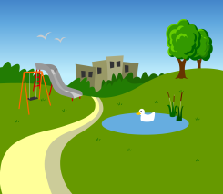 6. P _ _ _
- Answer the questions in the correct answers.
HOSPITAL BANK POLICE STATION
POST OFFICE SCHOOL PARK

 Excample: What is this?
It is a post office.

 1. What is this?
It is a ____________.

 2. What is this?
It is a ____________.

 3. What is this?
_____________________.

4. What is this?
_____________________.

Worksheet 2: Animal
- Directions: Complete the correct words under the pictures.

Name______________________________________ Class 1/___ Number_____

GIRAFFE BAER CROCODILE KANGAROO TIGER
LION SNAKE ELEPHANT ZEBRA

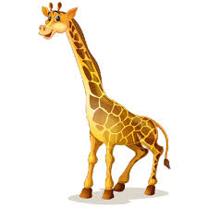

____TIGER_____

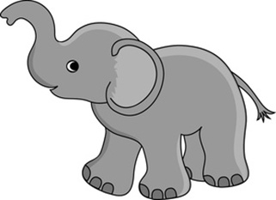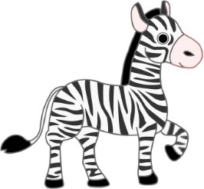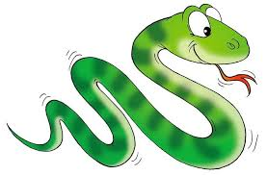

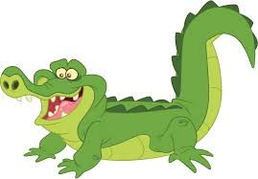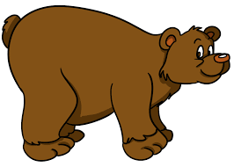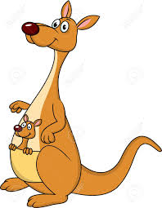

Worksheet 3: Occupation
1. Directions: Find the hidden words in the puzzle below.

Name___________________________________Class 1/___ Number_____

A | C | F | A | R | M | E | R | N | P | Q
S | O | L | D | I | E | R | R | U | S | T
I | O | B | O | U | V | W | X | R | Y | Z
N | K | K | C | A | B | C | D | S | E | F
G | N | L | T | E | A | C | H | E | R | G
E | M | P | O | S | T | M | A | N | H | I
R | O | O | R | S | T | U | D | E | N | T
P | O | L | I | C | E | M | A | N | J | K

COOK DOCTOR FARMER NURSE

SINGER POLICEMAN POSTMAN SOLDIER

STUDENT TEACHER

Worksheet 3: Occupation
- Directions: Put the correct words in the puzzle.

Name___________________________________Class 1/___ Number_____

P
C
N
D
O
O
S
K
T
S
F

S
P

COOK DOCTOR FARMER NURSE
SINGER POLICEMAN POSTMAN SOLDIER
STUDENT TEACHER

